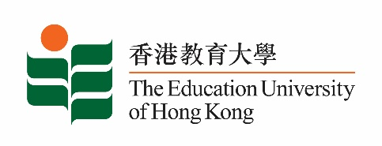

13 June 2025

**致：**  **传媒机构采访主任**

**To : News Editors**

**香港教育大学（教大）2025年6月16日至29日可供采访之活动一览**

**The Education University of Hong Kong (EdUHK) Events Calendar for 16 – 29 June 2025**

本校诚邀　贵机构派员采访下列活动。传媒查询，请联络教大传讯处（电话：2948 6050）。  
You are cordially invited to cover the events below. For media enquiries, please contact the Communications Office at 2948 6050.

以下活动或有人数限制，传媒请预先向主办部门登记。

There may be restrictions on the number of participants for the following event(s). Please contact the respective organiser(s) / department(s) for prior registration.

* **教大大埔校园**（新界大埔露屏路十号）

**EdUHK Tai Po Campus** (10 Lo Ping Road, Tai Po, New Territories)

|  |  |  |  |  |  |
| --- | --- | --- | --- | --- | --- |
| **日期**  **Date** | **时间**  **Time** | **活动**  **Event** | **地点**  **Venue** | **主办部门及公众查询**  **Organiser &**  **Public Enquiry** | **备注**  **Remarks** |
| 2025-06-24 | 2:00 pm –  5:00 pm | 小学人文科专业交流会议： 把握课程精神　探索教学创新  Primary Humanities Professional Exchange Conference: Embracing the Spirit of the Curriculum and Exploring Teaching Innovations | 教大大埔校园  D1-LP-03; D3-LP-07; D3-LP-13  D1-LP-03; D3-LP-07; D3-LP-13  EdUHK Tai Po Campus | 社会科学与政策研究学学系  Department of Social Sciences and Policy Studies  查询/ Enquiries:  李博士 Dr Li  电话 / Tel : 2948 7249  电邮/email : bymli@eduhk.hk  韦女士 Ms Wei  电话 / Tel : 2948 8710  电邮/email : jawei@eduhk.hk | 限受邀嘉宾入场。  Admission restricted to invited guests only. |